PCTB Land Test II

Draft Operations Plan

March 2020

The University of Texas at Austin

Deepwater Methane Hydrate Characterization & Scientific Assessment

DE-FE0023919

Contents

1 Executive Summary 2

2 Location 2

3 Well Plan 3

4 Testing Plan 4

4.1 PCTB Test 4

4.2 PDT Test 5

5 Geology 5

6 Schedule 6

7 Mobilization/Demobilization 8

7.1 Mobilization 8

7.2 Demobilization 9

8 Personnel 10

9 Safety 11

# Executive Summary

UT, with Pettigrew Engineering and Geotek Coring, Inc. (Geotek), will conduct a land-based coring test of the PCTB and T2P-PDT at Schlumberger CTTF from March 16-21, 2020. We will conduct three full-function coring tests each of the PCTB-FB and PCTB-CS, and two full-function tests of the T2P-PDT. These tests are intended verify the final design and functionality of the PCTB and T2P-MDT prior to deployment at sea during the UT-GOM2-2 drilling program.

# Location

The Pressure Coring Tool with Ball-valve (PCTB) Land Test will be conducted at the Cameron Testing & Training Facility (CTTF), in Cameron, Texas. CTTF is a full-service drilling rig with associated facilities, owned and operated by Schlumberger Technology Corporation (Schlumberger). CTTF enables the opportunity to test new technology and provide training in real-world drilling and wellsite environment, prior to field deployment. Detailed CTTF information is provided in Appendix A: *Cameron Test & Training Facility*, and Appendix B: *2016 Cameron Test & Training Facility Internal Rates & Policies*.

CTTF is located approximately 4 miles northwest of Cameron, TX (Figure 2‑1).

**Cameron Test & Training Facility**

**468 CR 143**

**Cameron, TX 76520**

**Lat: 30.9055**

**Long: -97.0197**

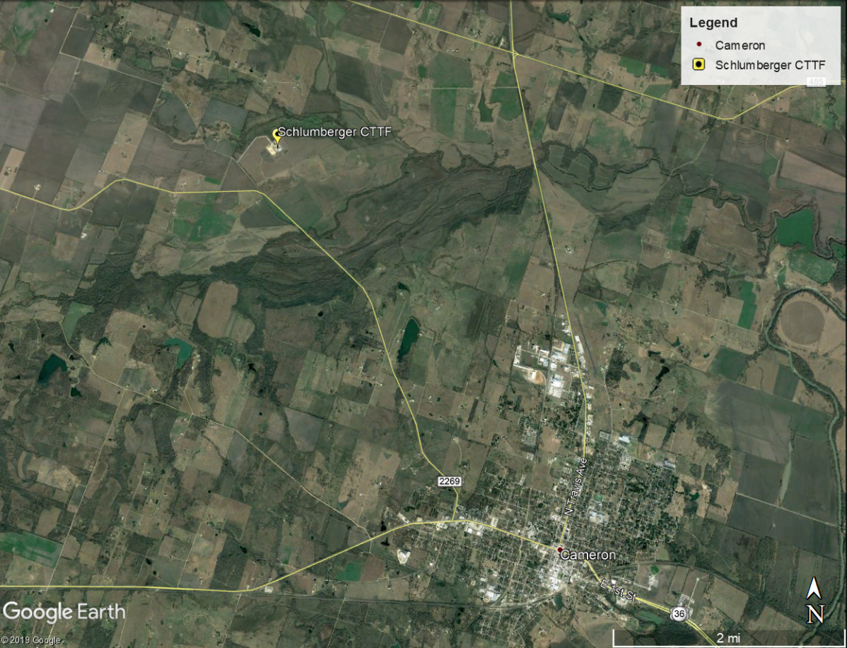

Figure ‑. Schlumberger Cameron Test and Training Facility Area Map

# Well Plan

Prior to the arrival of UT Austin at CTTF, Schlumberger will prepare a conductor hole for the PCTB test. The PCTB test will be conducted at CTTF Slot 6, Well 8. The TD to virgin formation at this location is approximately 3,400 ft TVD.

Schlumberger will drill out the cement plug at Slot 6, Well 8 to a depth of approximately 1628 ft bgs (TVD). Schlumberger will then kickoff at an angle of 2-degrees per 100 ft and sidetrack to a depth of 2050 ft bgs (MD). The sidetrack will then be brought back to vertical at a depth of 2250 ft bgs (MD). This will the first core-point depth for the PCTB test.

UT will conduct a total of six coring runs with the PCTB. Three runs will be conducted with the PCTB Face-Bit (PCTB FB), and three runs will be conducted with the PCTB Cutting Shoe (PCTB-CS). The PCTB core barrel length is approximately 10 feet, therefore UT will advance a maximum of 60 ft of penetration below the core-point depth of 2250 ft bgs (MD).

Schlumberger’s well plan for the PCTB test conductor hole is shown in Table 3‑1

Table ‑. Slot 06, Well 8, Sidetrack 19 Well Plan



# Testing Plan

## PCTB Test

The objective of the PCTB coring tests is to characterize the overall PCTB-FB function, focusing on core recovery capability, in simulated field conditions.

We will conduct three coring runs with the PCTB Face Bit (PCTB-FB). We will then change out the BHA and conduct three coring runs with the PCTB Cutting Shoe (PCTB-CS). The PCTB testing procedures, measurements, and analyses listed below will be carried out for each PCTB-CS and PCTB-FB coring run.

**General PCTB Coring Test Procedure**

1. Position BHA near test borehole bottom.
2. Deploy PCTB on wireline.
3. Pick up top drive, establish circulation, and core 10 ft or for 1 hour.
4. Lower wireline in borehole, latch onto PCTB, actuate PCTB, and recover PCTB via wireline.
5. Record PCTB retained pressure on surface, recover core from PCTB, refurbish PCTB.

**PCTB Coring Test Measurements**

1. The hydrostatic pressure at the BHA will be calculated and archived for comparison to fish pill pressure data.
2. PCTB autoclave internal pressures will be recorded electronically using fish pill recorders. Fish pill data will be downloaded to readable electronic files for review and archiving.
3. PCTB autoclave retained pressures will be determined on surface using either analog pressure gauges and/or pressure transducers. A record of retained pressure will be archived for all function tests.
4. PCTB boost reservoir pressure will be determined, prior to and after deployment, using either analog pressure gauges and/or pressure transducers. A record of boost reservoir pressure will be archived for all function tests.
5. Recovered core length will be measured, recorded, and archived.
6. Cored interval lengths will be determined from electronic drilling records and archived.
7. Bit advancement rate will be downloaded from electronic drilling records and archived.
8. The force required to unlatch the PCTB will be recorded for review and archiving.
9. Notes, and photographic evidence where applicable, regarding any failures will be archived for review.

**PCTB Coring Test Analysis**

1. The autoclave recorded fish pill pressure data will be reviewed and compared with calculated hydrostatic pressure to determine proper actuation and pressure boost function downhole.
2. The retained pressure data will be compared to pre-deployment PCTB pressure boost/regulator settings and calculated hydrostatic pressure to determine percentage of captured downhole pressure is retained on surface.
3. The pre and post deployment boost reservoir pressure will be reviewed to determine overall reservoir pressure drop.
4. The core length recovered will be compared to the cored interval length to determine percentage of core recovery.

**Core Curation**

All cores collected with the PCTB will be measured and photographed upon recovery, and the lithology will be described. Core quality and drilling-induced disturbance will be noted for each core. The core quality will be interpreted in the context of PCTB configuration, drilling parameters, and lithology. Cores will be archived at the UT Bureau of Economic Geology Austin Core Research Center.

## PDT Test

The objective of the PDT test is to verify the overall function of the PDT and T2P under simulated field conditions. We will conduct two full function tests with the PDT.

**General PDT/T2P Function Test Procedures**

1. Assemble T2P
2. Assemble PDT and Running/Pulling Tool (RPT).
3. Position BHA 20 m off test borehole bottom.
4. Deploy PDT
5. Note: Prior to landing stop and record PDT/T2P hanging weight.
6. Land PDT/T2P in BHA, note and record wireline depth.
7. Pick up wireline 15 m and record hanging weight.
8. Engage pump, establish circulation at 200 gpm, shut pump down.
9. Lower wireline landing in BHA, note and record wireline depth.
10. Pick up wireline 10 m and record hanging weight.
11. Recover PDT.

**PDT/T2P Function Test Measurements**

1. Compare recorded hanging weights to calculated hanging weights to confirm down hole release.
2. Compare recorded wireline depths to calculated depths to confirm PDT stroke.
3. Compare T2P temperature and pressure data to calculated values.
4. All deployment parameters, including wireline position, will be noted and archived along with all electronic drilling data recorded for review.
5. Notes and photographic evidence, where applicable, regarding any failures will be archived for review.

**PDT/T2P Function Test Analysis**

1. Wireline weight loss and wireline position at release and re-latch will be compared to calculated values to confirm proper PDT function.
2. Borehole temperature and pressure will be compared to calculated values to confirm proper T2P function.

# Geology

Pressure cores collected from 2248 - 2308 ft TVD will encounter limestone and marl from the Georgetown Formation. This formation is of Middle Cretaceous Age (Albian) and likely contains fossiliferous and bioturbated intervals. Thin shale beds may also be encountered within the Georgetown Formation. Gamma ray logs from CTTF suggest variable clay content in this interval.

# Schedule

Pre-test activities will be conducted by Schlumberger and Geotek during the week of 3/9/20. UT will mobilize to CTTF on Monday, 3/16/20. It is anticipated that testing will commence late Monday or early Tuesday and continue into Saturday, 3/21/20, for a total duration of 6 days.

UT, Pettigrew Engineering, and Geotek will work approximately 12-hour shifts, from 7AM-7PM. Schlumberger will staff the site in two-12-hour shifts from 7AM-7PM, and 7PM-7AM. UT and the coring test team will delegate tasks to the Schlumberger night crew whenever possible.

The Land Test schedule is shown in Table 6‑1, and Table 6‑2.

Table ‑. Land Test Schedule, week of March 9, 2020.



Table ‑. Land Test Schedule, week of March 16, 2020.



The UT Austin personnel CTTF staffing plan is shown in Table 6‑3.

Table ‑. UT Austin personnel CTTF staffing plan

|  |  |  |  |  |  |  |  |
| --- | --- | --- | --- | --- | --- | --- | --- |
| UT Team | 16-Mar | 17-Mar | 18-Mar | 19-Mar | 20-Mar | 21-Mar | 22-Mar |
| Mon | Tue | Wed | Thu | Fri | Sat | Sun |
| *Mob, FB1* | *FB1,2* | *FB3* | *CS1,2,3* | *CS3, PDT* | *PDT* | *Demob* |
| Phillips | X | X | X | X | X | X |  |
| Murphy | X | X | X |  |  |  |  |
| Fang |  |  | X | X | X |  |  |
| Flemings |  |  |  | X | X |  |  |
| Price |  |  |  | X | X | X |  |
| O'Connell |  |  |  | X | X | X |  |

# Mobilization/Demobilization

## Mobilization

|  |  |  |  |  |  |  |  |  |
| --- | --- | --- | --- | --- | --- | --- | --- | --- |
| **ITEM** | **POINT OF ORIGIN** | | **TRANSPORTATION** | | | **DESTINATION** | | **NOTES** |
| **Location** | **Contact** | **Pick-Up Date** | **Deliv. Date** | **Contact** | **Location** | **Contact** |
| Heavy Tools Conex | Geotek 3350 W Directors Row SLC, UT 84104 | Geotek Mike Mimitz 413-297-3805 | 3/11/2020 | 3/13/2020 | Geotek Mike Mimitz 413-297-3805 | CTTF 468 CR 143 Cameron TX 76520 | Michael Schwartz 713-725-8797 |  |
| PCTB Service Conex | Geotek 3350 W Directors Row SLC, UT 84104 | Geotek Mike Mimitz 413-297-3805 | 3/11/2020 | 3/13/2020 | Geotek Mike Mimitz 413-297-3805 | CTTF 468 CR 143 Cameron TX 76520 | Michael Schwartz 713-725-8797 |  |
| 5" Drill Pipe (Qty 100) | Tuboscope  Sheldon North 10222 Sheldon Rd. Houston, TX 77049 | Leslie Johnson - Supervisor leslie.johnson@nov.com Shipping/Receiving  281-456-6175 | 3/12/2020 | 3/12/2020 | Sparta Logistics Eric Djolic 773-774-4333 | CTTF 468 CR 143 Cameron TX 76520 | Michael Schwartz 713-725-8797 | Pettigrew will be onsite on 3/12 at Tuboscope during pick-up. Must arrive at SLB before 3PM |
| 5-1/2" Lifting Plugs | M.M Industries Inc.  Morgan City, LA | Kenneth Hall MMIndustries  985-384-1220 | 2/19/2020 | 2/21/2020 | UPS 1ZA50E130392205727 | CTTF 468 CR 143 Cameron TX 76520 | Michael Schwartz 713-725-8797 | Michael Schwartz confirmed receipt. |

## Demobilization

|  |  |  |  |  |  |  |  |  |
| --- | --- | --- | --- | --- | --- | --- | --- | --- |
| **ITEM** | **POINT OF ORIGIN** | | **TRANSPORTATION** | | | **DESTINATION** | | **NOTES** |
| **Location** | **Contact** | **Pick-Up Date** | **Deliv. Date** | **Contact** | **Location** | **Contact** |
| Heavy Tools Conex | CTTF 468 CR 143 Cameron TX 76520 | Michael Schwartz 713-725-8797 | 3/22/2020 | 3/22/2020 | Geotek Mike Mimitz 413-297-3805 | Geotek 3350 W Directors Row SLC, UT 84104 | Geotek Mike Mimitz 413-297-3805 | Geotek will complete demob activities in SLC |
| PCTB Service Conex | CTTF 468 CR 143 Cameron TX 76520 | Michael Schwartz 713-725-8797 | 3/22/2020 | 3/22/2020 | Geotek Mike Mimitz 413-297-3805 | Geotek 3350 W Directors Row SLC, UT 84104 | Geotek Mike Mimitz 413-297-3805 | Geotek will complete demob activities in SLC |
| 5" Drill Pipe (1) (Qty 100) | CTTF 468 CR 143 Cameron TX 76520 | Michael Schwartz 713-725-8797 | 3/22/2020 | 3/22/2020 | Sparta Logistics Eric Djolic 773-774-4333 | Texflow 397 CR 142 Alvin, TX 77511 | Kim Rebresh 281-331-5611 ksftexflow@yahoo.com | Pipe will first be transported to Texflow for cleaning |
| 5" Drill Pipe (2) (Qty 100) | Texflow 397 CR 142 Alvin, TX 77511 | Kim Rebresh 281-331-5611 ksftexflow@yahoo.com | Est. 3/25/2020 | Est. 3/25/2020 | Sparta Logistics Eric Djolic 773-774-4333 | Tuboscope  Sheldon North 10222 Sheldon Rd. Houston, TX 77049 | Leslie Johnson - Supervisor leslie.johnson@nov.com Shipping/Receiving  281-456-6175 | Pipe will then be transported back to Tuboscope |
| 5-1/2" Lifting Plugs | CTTF 468 CR 143 Cameron TX 76520 | Michael Schwartz 713-725-8797 | 3/22/2020 | 3/22/2020 | Geotek Mike Mimitz 413-297-3805 | Geotek 3350 W Directors Row SLC, UT 84104 | Geotek Mike Mimitz 413-297-3805 | Lifting Plugs should be secured in Heavy Tools Conex |

# Personnel

|  |  |  |  |  |
| --- | --- | --- | --- | --- |
| **ORG** | **NAME** | **ROLE** | **PHONE** | **EMAIL** |
| UT | Peter Flemings | Principle Investigator | C: 512-750-8411 | [pflemings@jsg.utexas.edu](mailto:pflemings@jsg.utexas.edu) |
| UT | Stephen Phillips | Lead Scientist | C: 603-380-8522 | [stevep@ig.utexas.edu](mailto:stevep@ig.utexas.edu) |
| UT | Yi Fang | Training | C: 562-284-7949 | [yi.fang@jsg.utexas.edu](mailto:yi.fang@jsg.utexas.edu) |
| UT | Aaron Price | PDT test lead | C: 512-633-9462 | [aaron.price@utexas.edu](mailto:aaron.price@utexas.edu) |
| UT | Zachary Murphy | Training | C: 626-590-6325 | [zmurphy@utexas.edu](mailto:zmurphy@utexas.edu) |
| UT | Joshua O'Connell | Data Mgmt, Other | C: 304-322-1088 | [josh.oconnell@utexas.edu](mailto:josh.oconnell@utexas.edu) |
| UT | Jesse Houghton | Observe | C: 970-270-0490 | [jesse@ig.utexas.edu](mailto:jesse@ig.utexas.edu) |
| UT | C. Panagopulos | Observe | C: 512-471-0160 | [costa@ig.utexas.edu](mailto:costa@ig.utexas.edu) |
| UT | Ben Hester | Logistics | O: 512-471-0413 | [ben@ig.utexas.edu](mailto:ben@ig.utexas.edu) |
| USGS | Tim Collett | Visitor | C: 720-936-2372 | [tcollett@usgs.gov](mailto:tcollett@usgs.gov) |
| US DOE | Rick Baker | Visitor | - | [Richard.Baker@netl.doe.gov](mailto:Richard.Baker@netl.doe.gov) |
| US DOE | Maria Vargas | Visitor | - | [Maria.Vargas@netl.doe.gov](mailto:Maria.Vargas@netl.doe.gov) |
| US DOE | Maureen Davison | Visitor | - | [Maureen.Davison@netl.doe.gov](mailto:Maureen.Davison@netl.doe.gov) |
| US DOE | Gabby Intihar | Visitor | - | [Gabby.Intihar@hq.doe.gov](mailto:Gabby.Intihar@hq.doe.gov) |
| US DOE | Janet Laukatis | Visitor | - | [Janet.Laukatis@netl.doe.gov](mailto:Janet.Laukatis@netl.doe.gov) |
| Tuboscope | Leslie Johnson | IODP Pipe yard | O: 281-456-6175 | [leslie.johnson@nov.com](mailto:leslie.johnson@nov.com) |
| Texflow | Kim Rebresh | Pipe Cleaning | O: 281-331-5611 | [ksftexflow@yahoo.com](mailto:ksftexflow@yahoo.com) |
| Sparta | Eric Djolic | Trucking | O: 773-774-4333 | [operations@spartausa.net](mailto:operations@spartausa.net) |
| Schlum. | Michael Schwartz | Test Coordinator | C: 713-725-8797 | [Mschwartz@slb.com](mailto:Mschwartz@slb.com) |
| Schlum. | Donald Shapiro | Test Coordinator | C: 713-560-5929 O: 979-268-6665 | [Shaprio2@slb.com](mailto:Shaprio2@slb.com) |
| Schlum. | Doug Cox | Rig Superintendent |  |  |
| Schlum. | Russell Wagstaff | CTTF Manager | O: 281-285-3454 | [Rwagstaff@slb.com](mailto:Rwagstaff@slb.com) |
| Schlum. | Teresa Garza | CTTF HS&E | O: 254-697-4488 | [Tgarza@slb.com](mailto:Tgarza@slb.com) |
| Pettigrew | Tom Pettigrew | Lead Engineer | C: 979-450-0422 | [Pettigrew.engineering@windstream.net](mailto:Pettigrew.engineering@windstream.net) |
| IODP | John Van Hyfte | Eng. Supervisor | O: 979-845-2294 | [Vanhyfte@iodp.tamu.edu](mailto:Vanhyfte@iodp.tamu.edu) |
| IODP | Bill Rhinehart | Ops. Eng | O: 979-862-1961 C: 936-703-7297 | [rhinehart@iodp.tamu.edu](mailto:rhinehart@iodp.tamu.edu) |
| Geotek | Mike Mimitz | Coring Contractor | C: 413-297-3805 | [Mike.Mimitz@geotekcoring.com](mailto:Mike.Mimitz@geotekcoring.com) |
| Geotek | John Roberts | Coring Contractor | - | - |
| Geotek | Matt Selman | Coring Contractor | - | - |
| Geotek | Alex Burrows | Coring Contractor | - | - |
| Geotek | Dan Minarich | Coring Contractor | - | - |

# Safety

Upon arriving at CTTF, all personnel will be required to undergo a brief safety training provided by the HS&E representative, Teresa Garza. UT Austin will coordinate group arrivals to minimize the need for one-off/individual training.

Schlumberger requires the following personal protective equipment (PPE) for all personnel working on site at CTTF:

1. Hard hat
2. Safety glasses
3. Hearing protection
4. Impact-resistant gloves
5. Work boots with steel/composite safety toe
6. FR coveralls